Phase I Methods – IDAHO (ID)

A. Plots of Predictors vs. HPI (non-simple return)

Original HPI Series
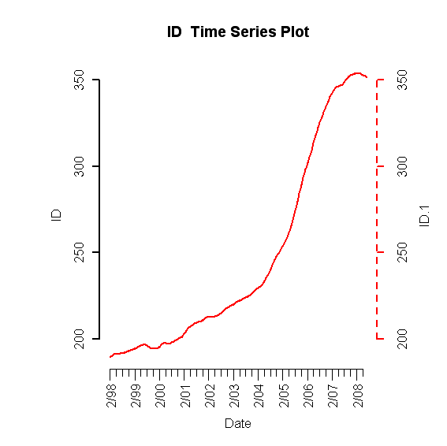
Building Permits
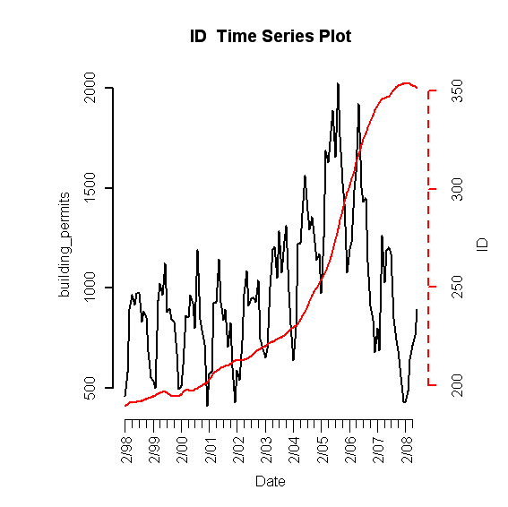
Foreclosures
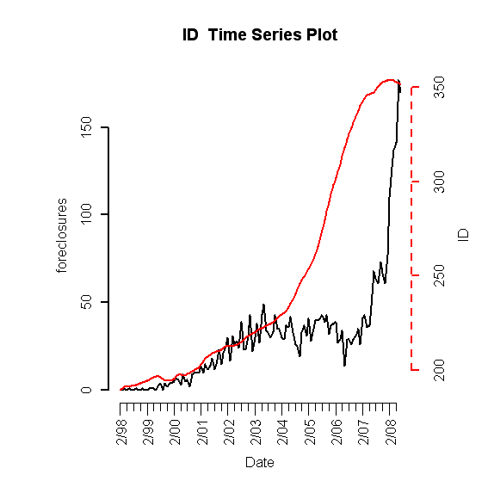

Population Size
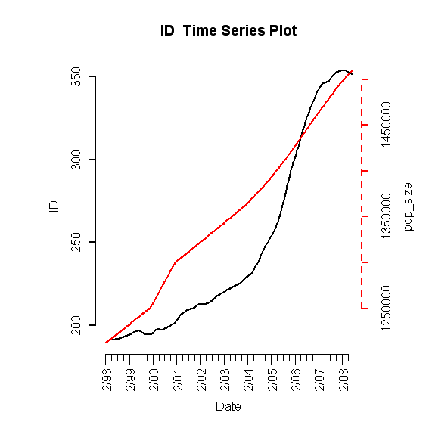
Unemployment Rate
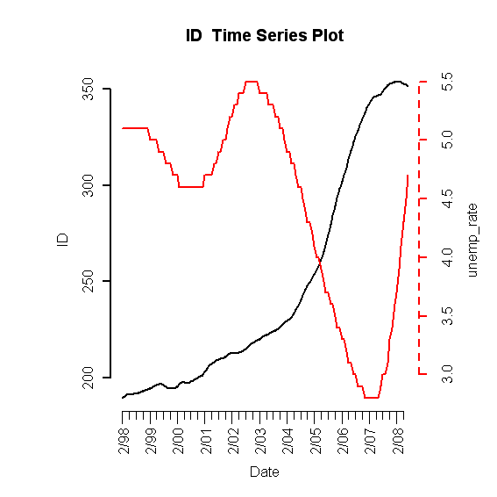
Mortgage Originations
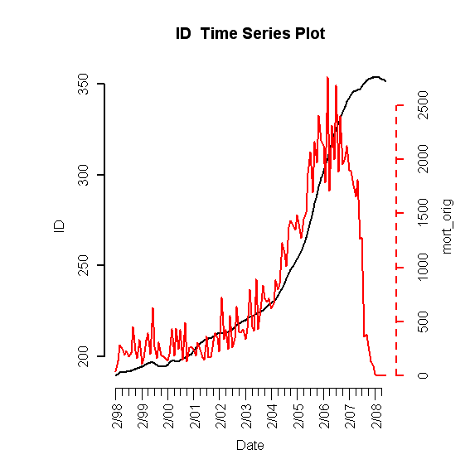

30-Year Commitment Rate
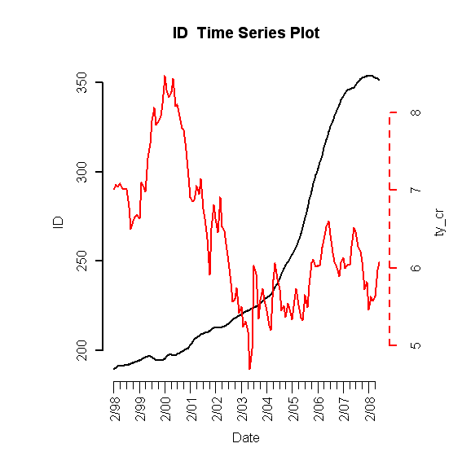
Median Income
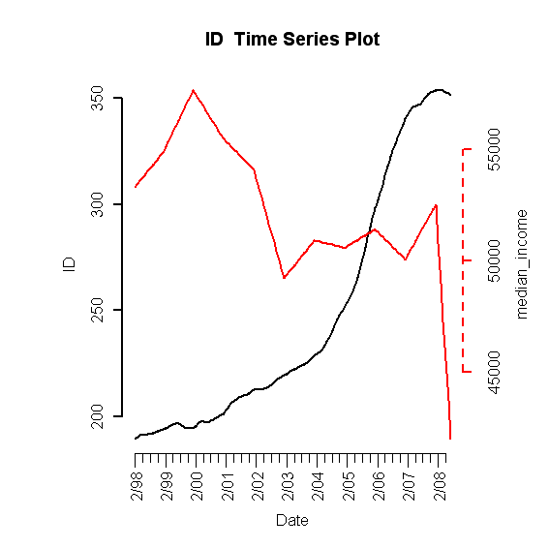
B. Scatterplots (simple return)

HPI vs. HPI
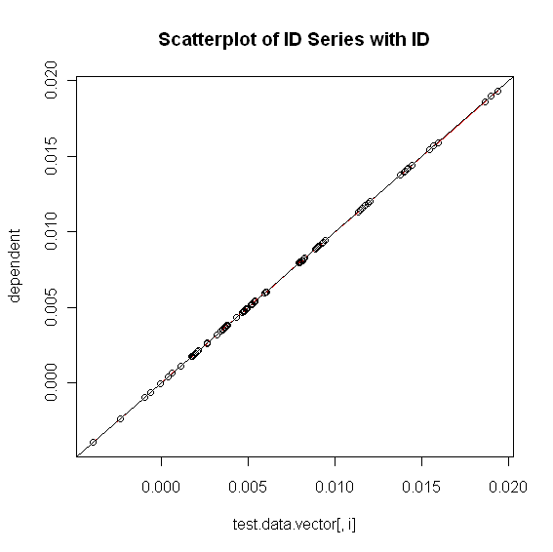

HPI vs. Building Permits
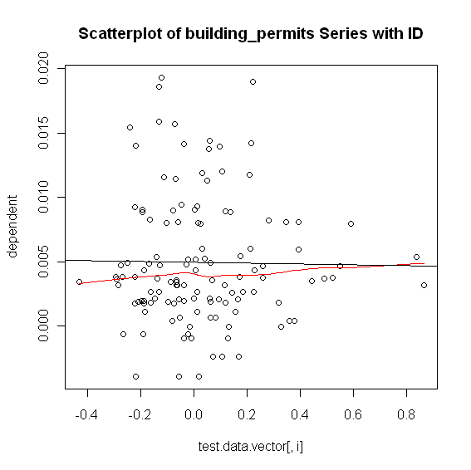
HPI vs. Foreclosures
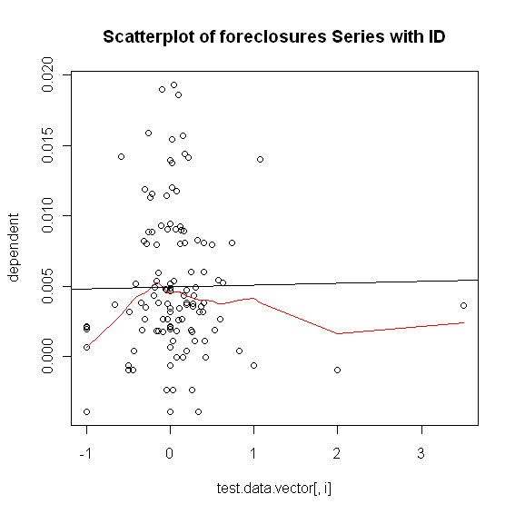
HPI vs. Population Size
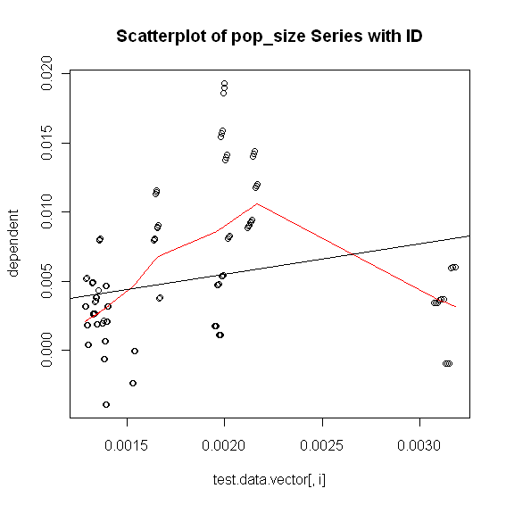

HPI vs. Unemployment Rate
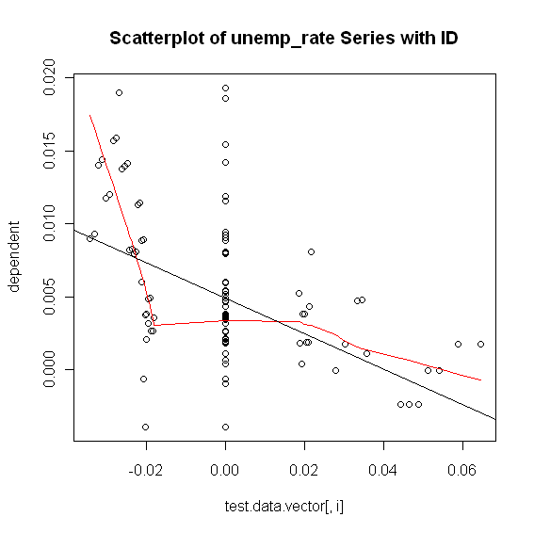
HPI vs. Mortgage Originations
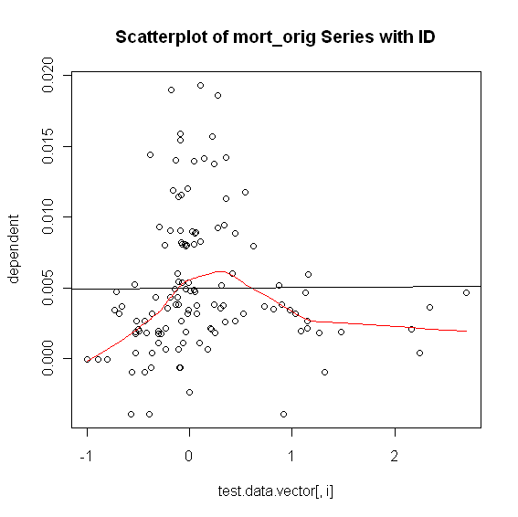
HPI vs. 30-Year Commitment Rate
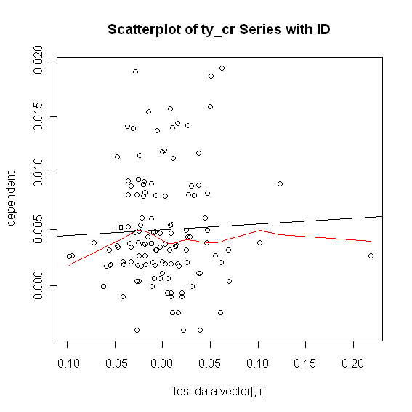

HPI vs. Median Income
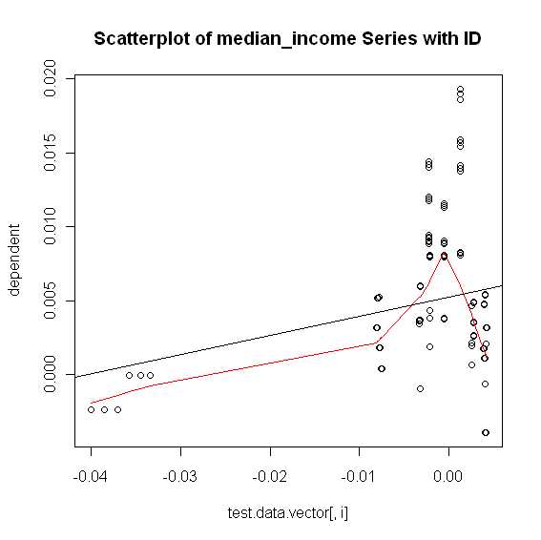
C. Exhaustive Stepwise Regression
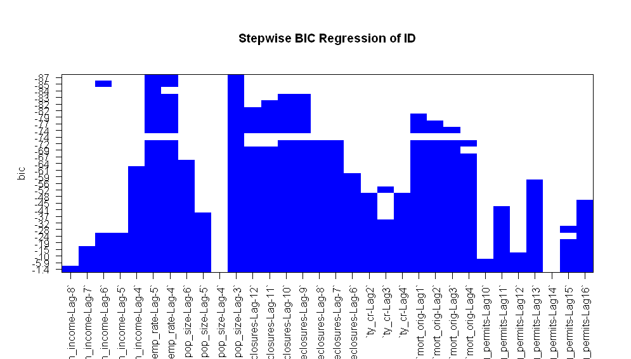

D. Final RLM Model
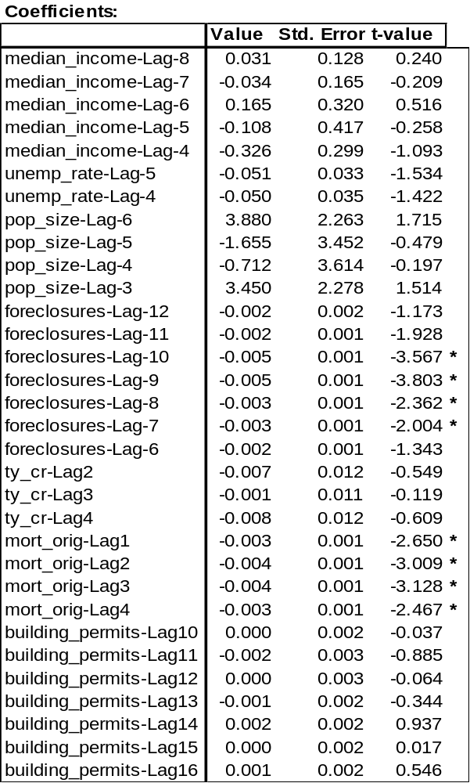

1. Phase I

ACF of Residuals
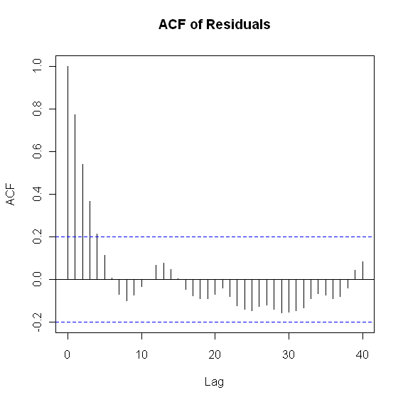
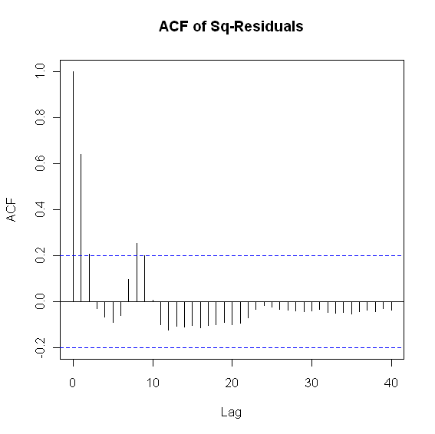
PACF and ADF Test

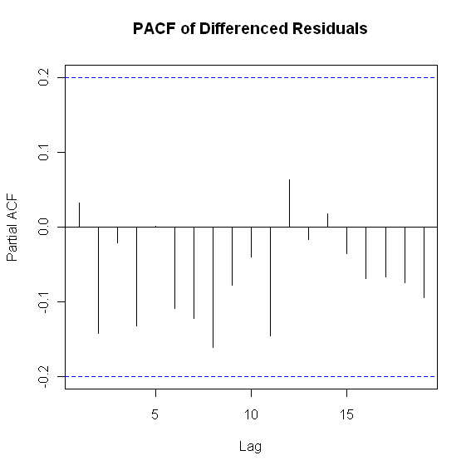
> adf.test(y$residuals, k = 3)
Augmented Dickey-Fuller Test
data: y$residuals
Dickey-Fuller = -3.6903, Lag order = 3, p-value = 0.02902
alternative hypothesis: stationary

ARIMA(1,0,0) with zero mean
Call: arima(x = resid.data, order = c(1, 0, 0), include.mean = FALSE)

Coefficients:
ar1
0.7702
s.e. 0.0629
sigma^2 estimated as 6.112e-06: log likelihood = 444.17
AIC = -884.33 AICc = -884.2 BIC = -879.18

Box-Ljung Test

> Box.Ljung.test(arima.fit$resid,lag = 12, adj.DF = 12-params)
Q(12) P-value df
7.384673 0.7671 11

> Box.Ljung.test(arima.fit$resid^2,lag = 12, adj.DF = 12)
Q(12) P-value df
25.26165 0.0136 12

2. Phase II

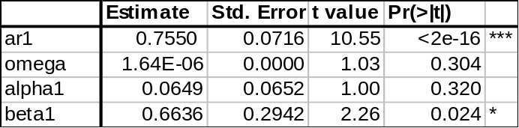

ACF of Residuals
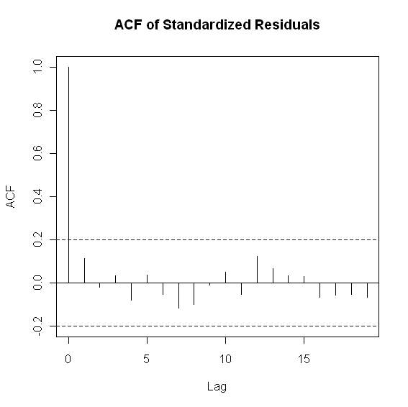
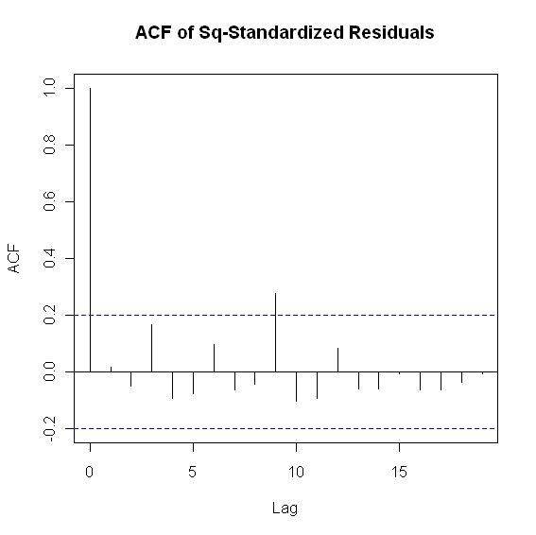

Box-Ljung Test

> Box.Ljung.test(sresi, lag = 12, adj.DF = 12-meanParams)
Q(12) P-value df
7.3162 0.7729 11
> Box.Ljung.test(sresi^2, lag = 12, adj.DF = 12-volParams )
Q(12) P-value df
17.41181 0.0657 10

